# VPC (Virtual Private Cloud)

## Create VPC

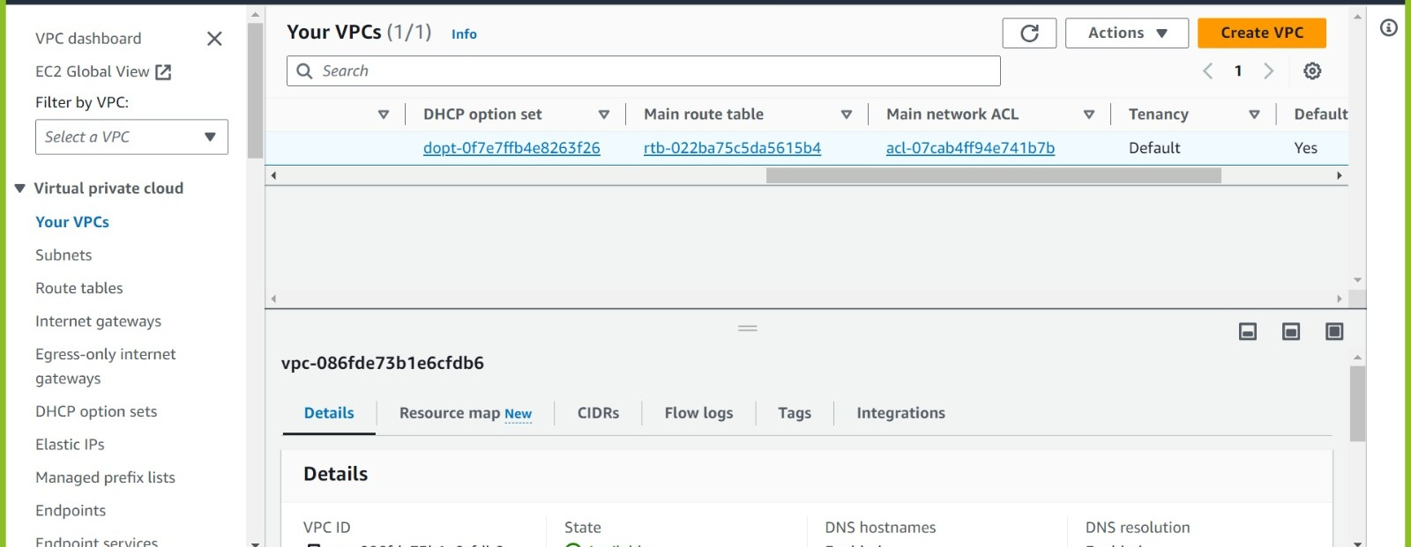

We have a default VPC available in every region.

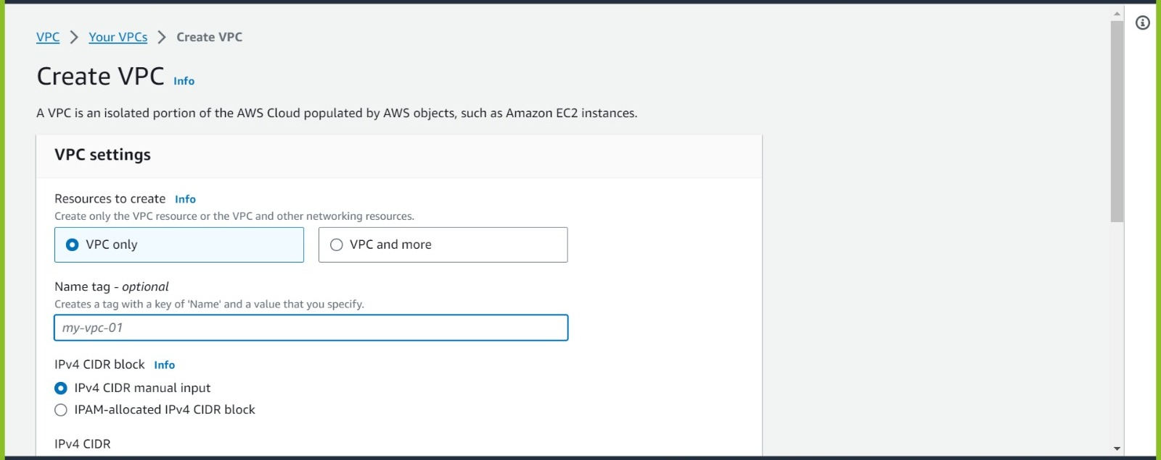

* First, we have the VPC only option but now we are having another option as VPC and more
* VPC and more is much smarter as in one go, we can create VPC, Subnets, RouteTables, Internet gateway and so on.

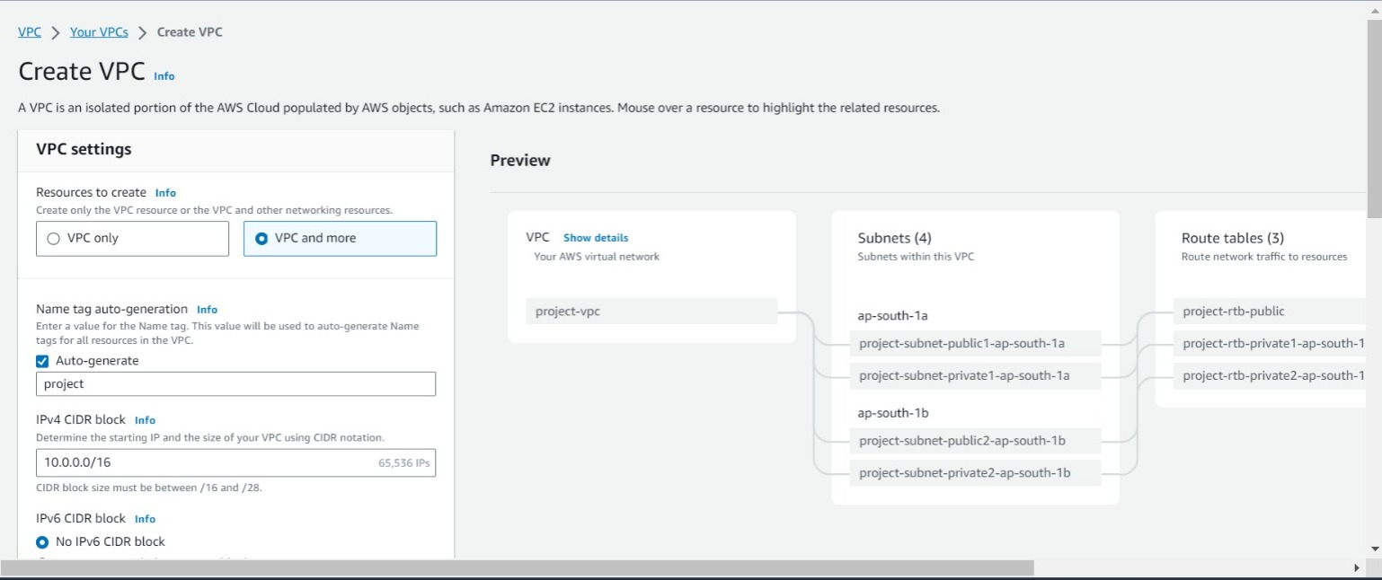

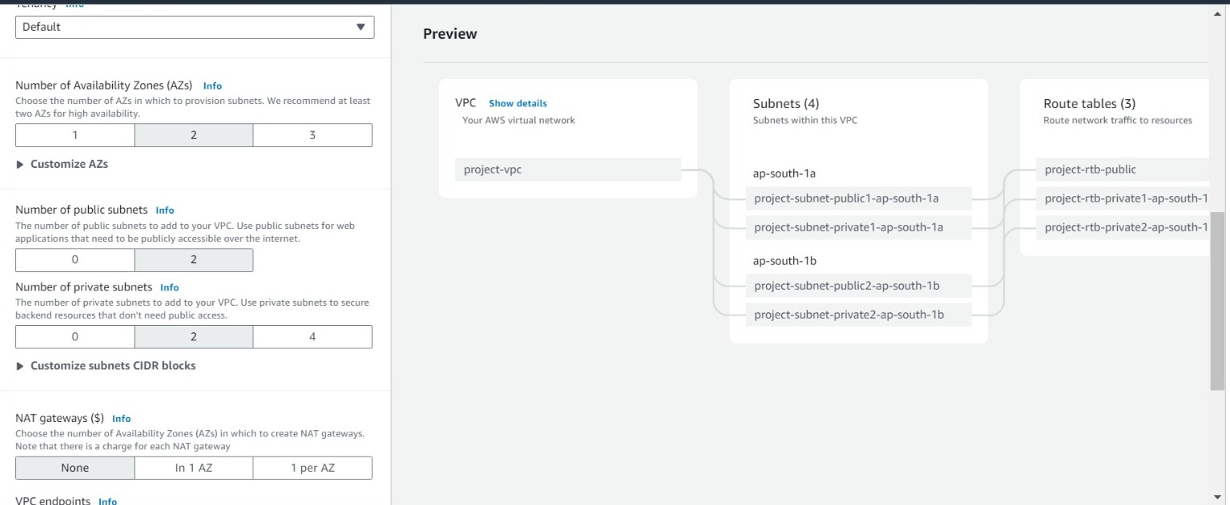

Here you can see proper view of our VPC

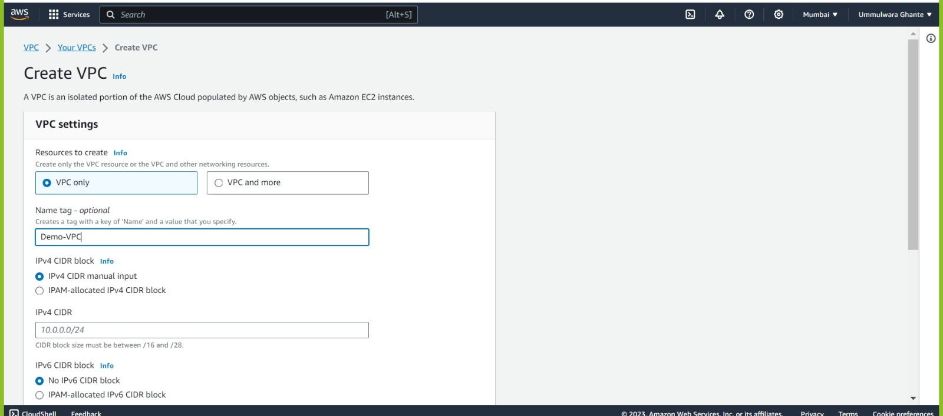

In IPV4 CIDR block we can have a manual input as 10.0.0.0/16.

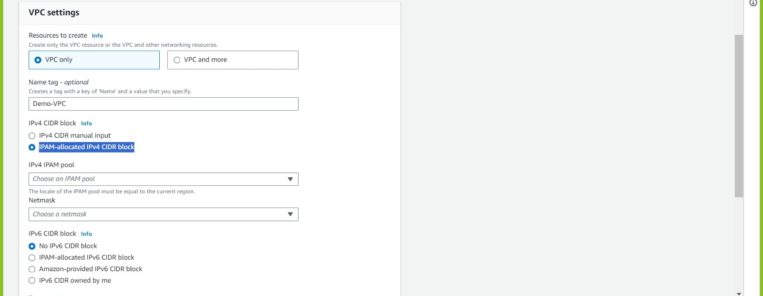

* **IPAM—IP Address Management**
* Here you create one pool of different IP’S and AWS will automatically allocate IPs from that pool.
* In this we have different range of IP’s (e.g., 10.0.0/16, 10.1.0.0/16)

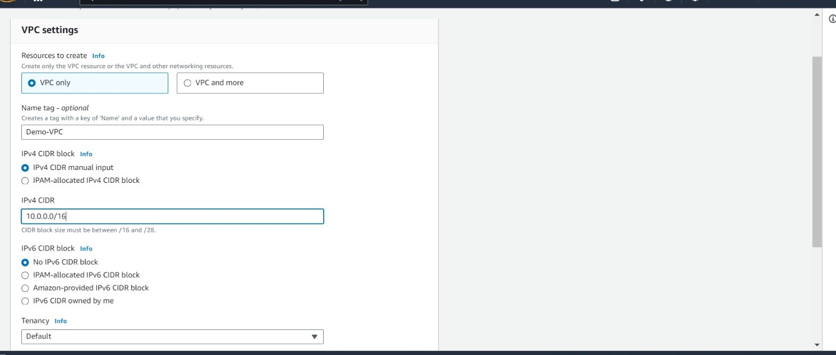

* Manually we have created one CIDR that is 10.0.0.0/16

**VPC CIDR Options for network range**

* 10.0.0.0/16 🡪 10.255.0.0/16 (255 networks)
* 172.16.0.0 /16🡪 172.30.0.0/16 (15 networks)
* 192.168.0.0/20 🡪 192.168.255.255/20 (1 network)
* 172.31.0.0/16 🡪 reserved for default VPC in any region so best practice not to use this IP except default VPC IP we can use any IP’s
* If we use default VPC then overriding can occur.
* Between this network range we can give the IP’s for VPC
* These are all the Private IP ranges of CIDR

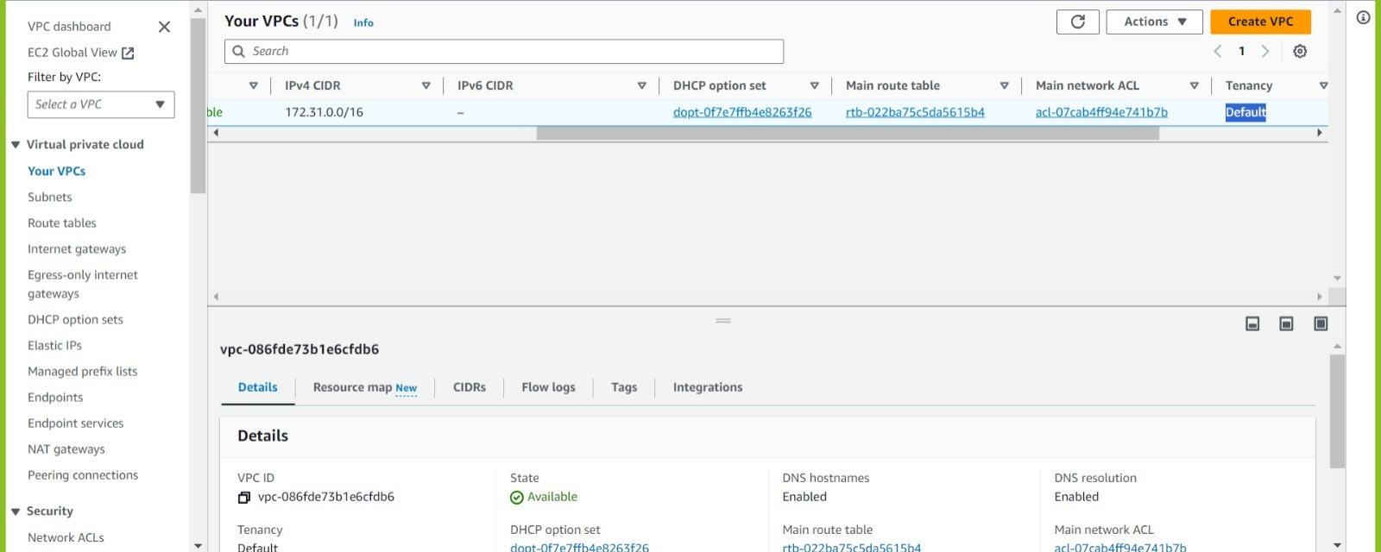



<https://docs.aws.amazon.com/vpc/latest/userguide/vpc-cidr-blocks.html#vpc-sizing-ipv4>

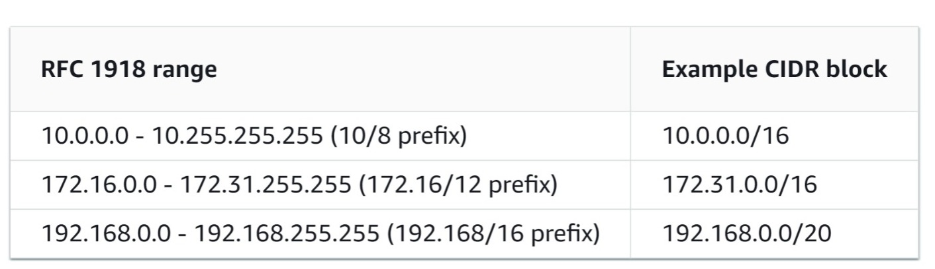

**VPC CIDR OPTIONS**

**Important**

Some AWS services use the 172.17.0.0/16 CIDR range. To avoid future conflicts, do not use this range when creating your VPC. For example, services like AWS Cloud9 or Amazon Sage Maker can experience IP address conflicts if the 172.17.0.0/16 IP address range is already in use anywhere in your network.

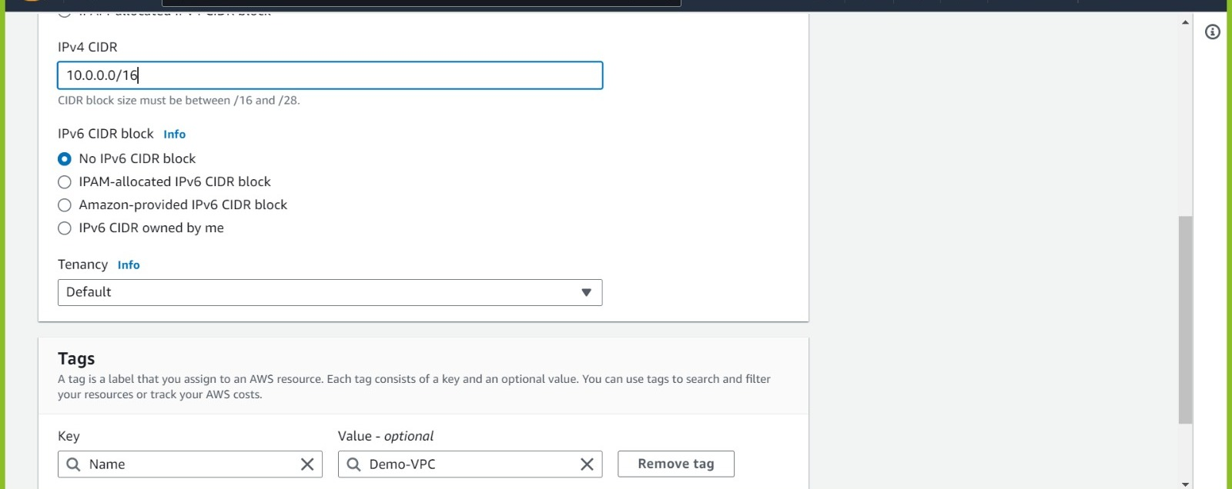

* If we keep Tenancy as default then it can be shared.
* We can also provide IPV6 address for VPC and EC2 instance.

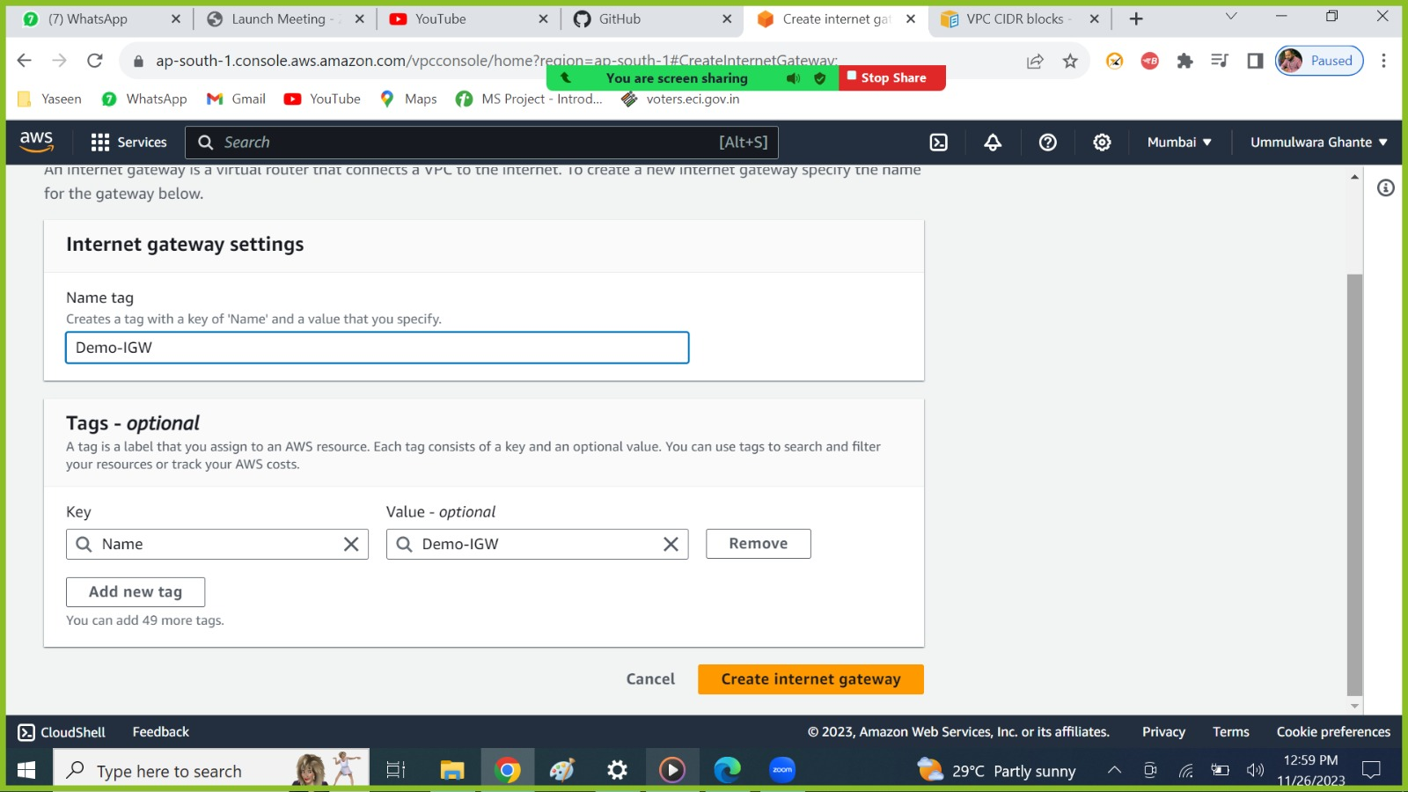

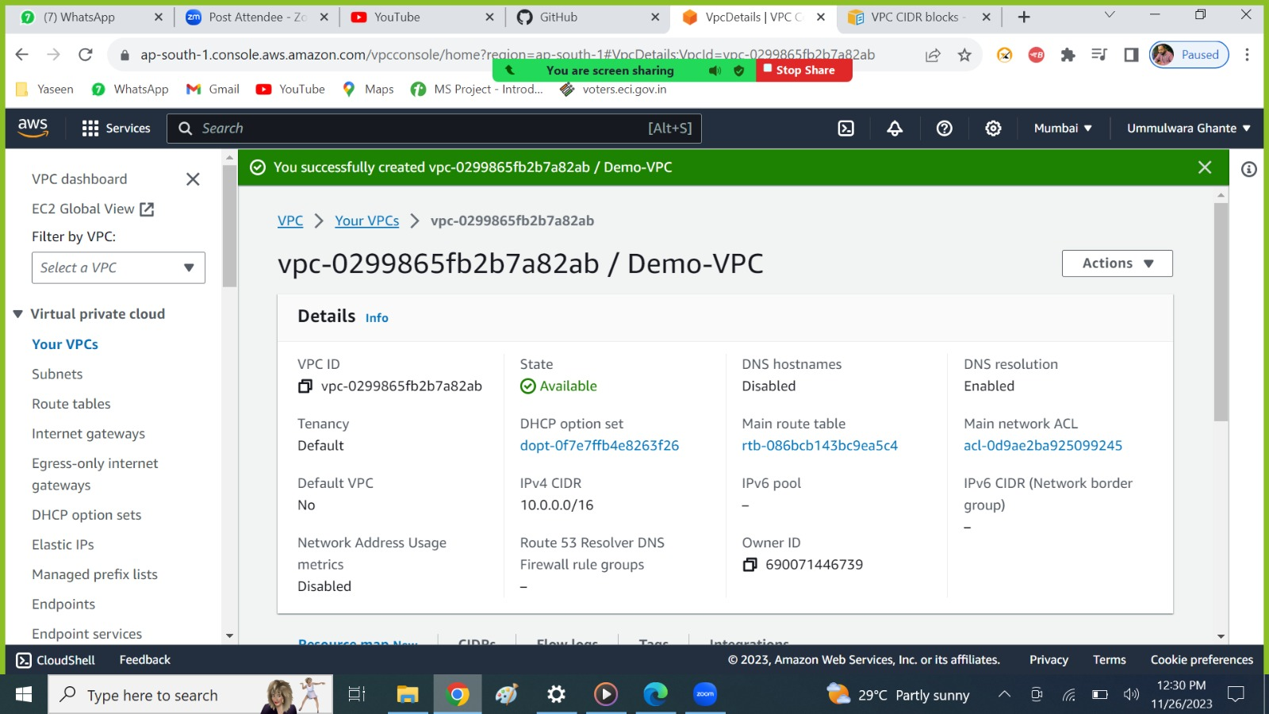

VPC created successfully

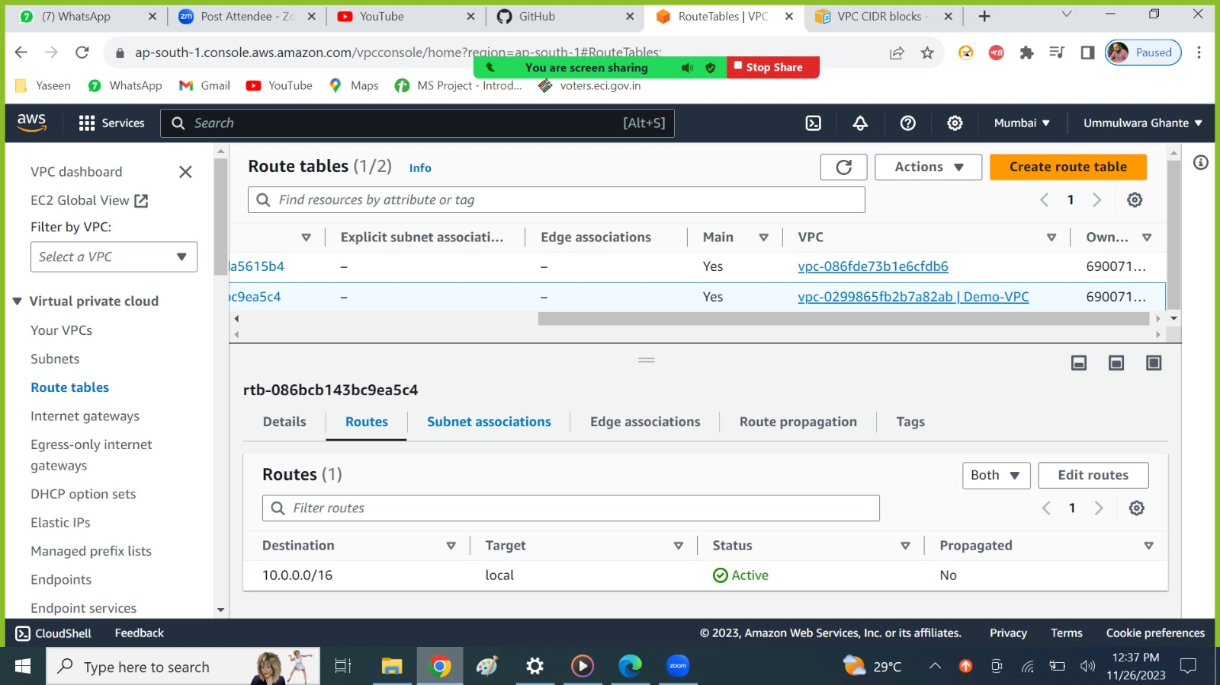

* Whenever we create VPC by default one RT gets automatically created (Main RT)
* When ever we create a subnet then by default it will get associated with the main RT (demo VPC) which has been created with the VPC.

EG:

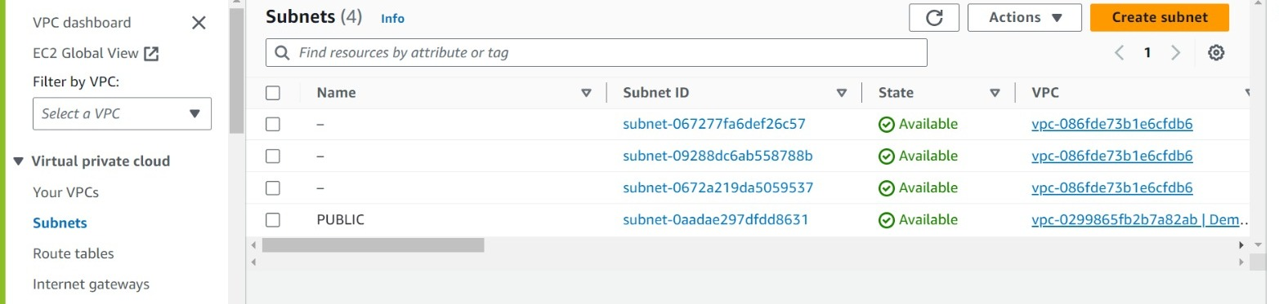

**For Example:** We have created one Public Subnet as you can see when we create subnet by default it gets associated with the Route table of (Demo-VPC ) which gets created automatically when we create a VPC.

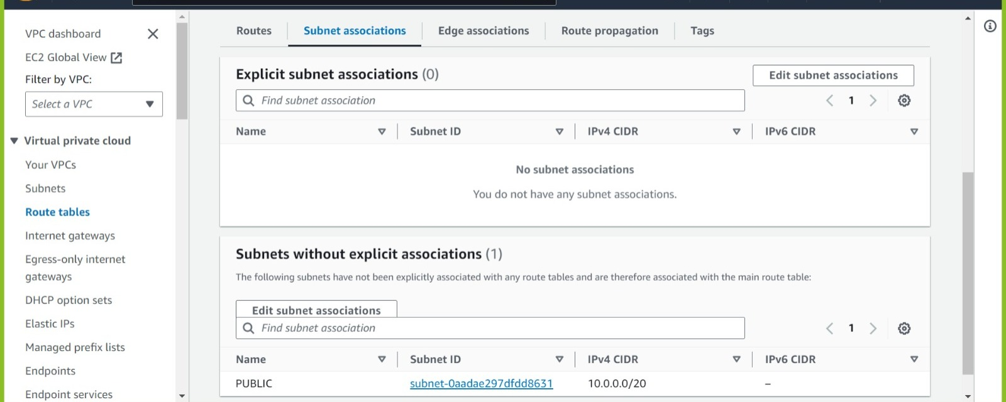

Whenever we create a VPC one main RT gets created and it will implicitly get associated to all the subnets created in that VPC.

## Create Internet Gateway

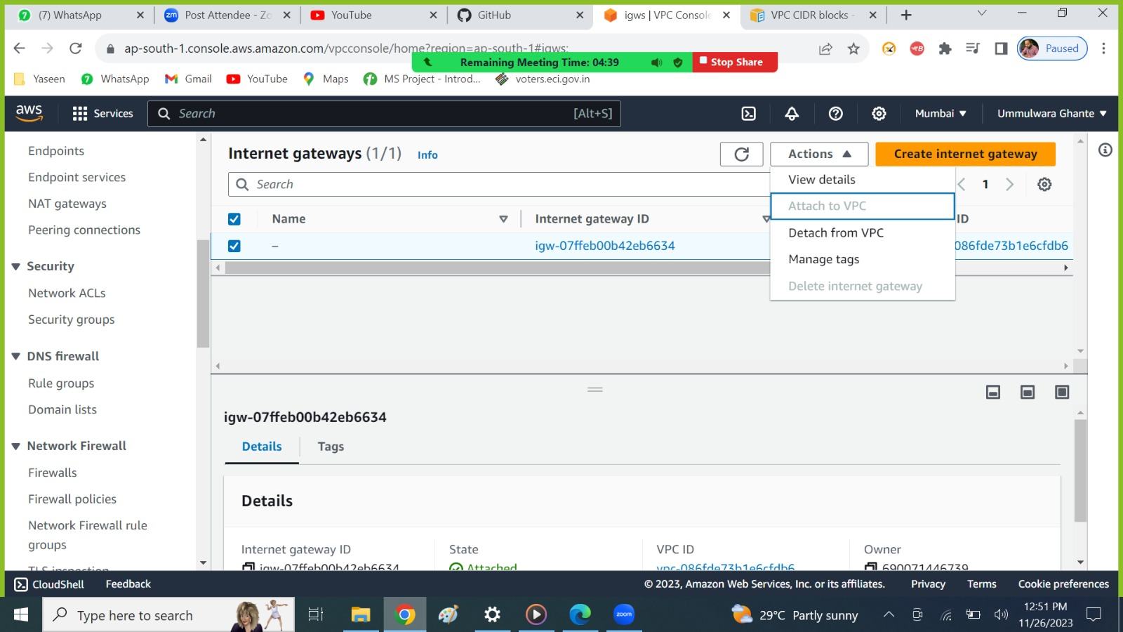

* This is the IGW of default VPC and is attached to the default VPC
* As you can see in the action, we cannot attach this IGW to our demo VPC.
* **NOTE :** As one IGW can only be attached to one VPC and vice-versa.
* So now you need to create another IGW for the demo VPC

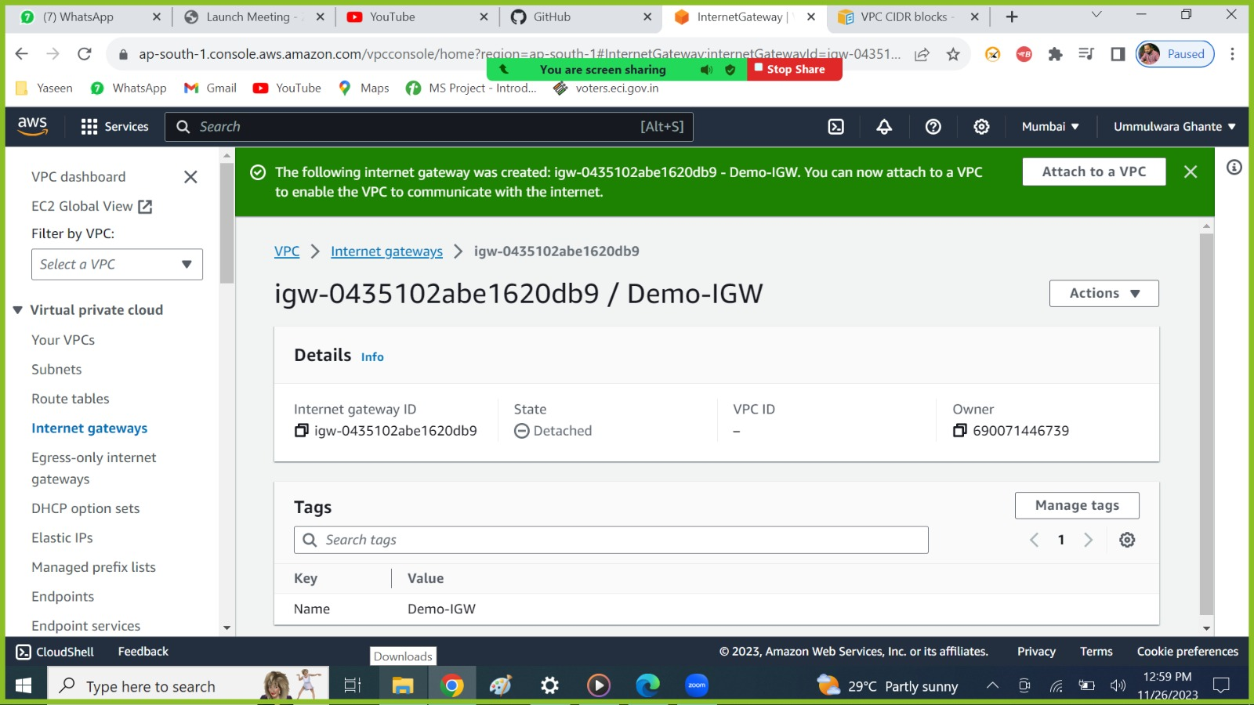

As we can see this is detached, we need to attach to our VPC.

## 3. Attach IGW to VPC

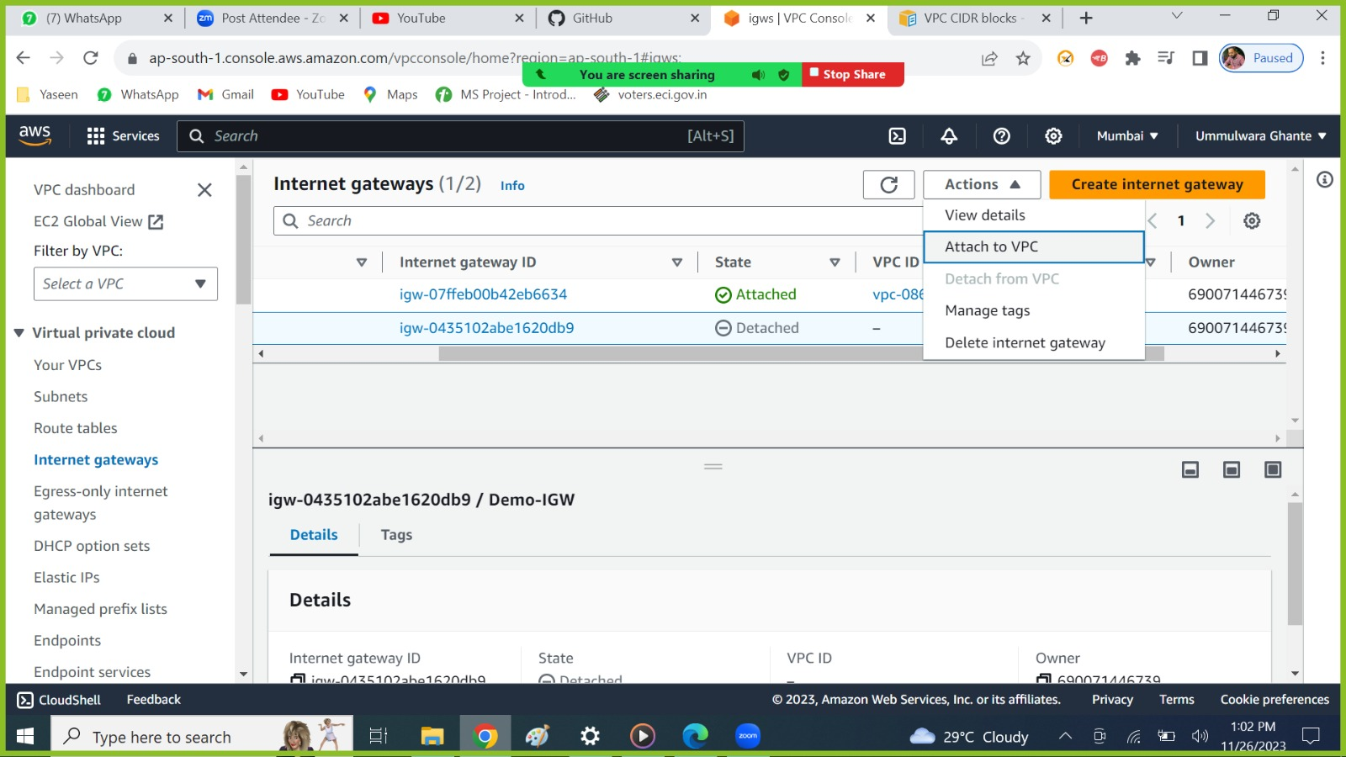

From here also you can attach the VPC

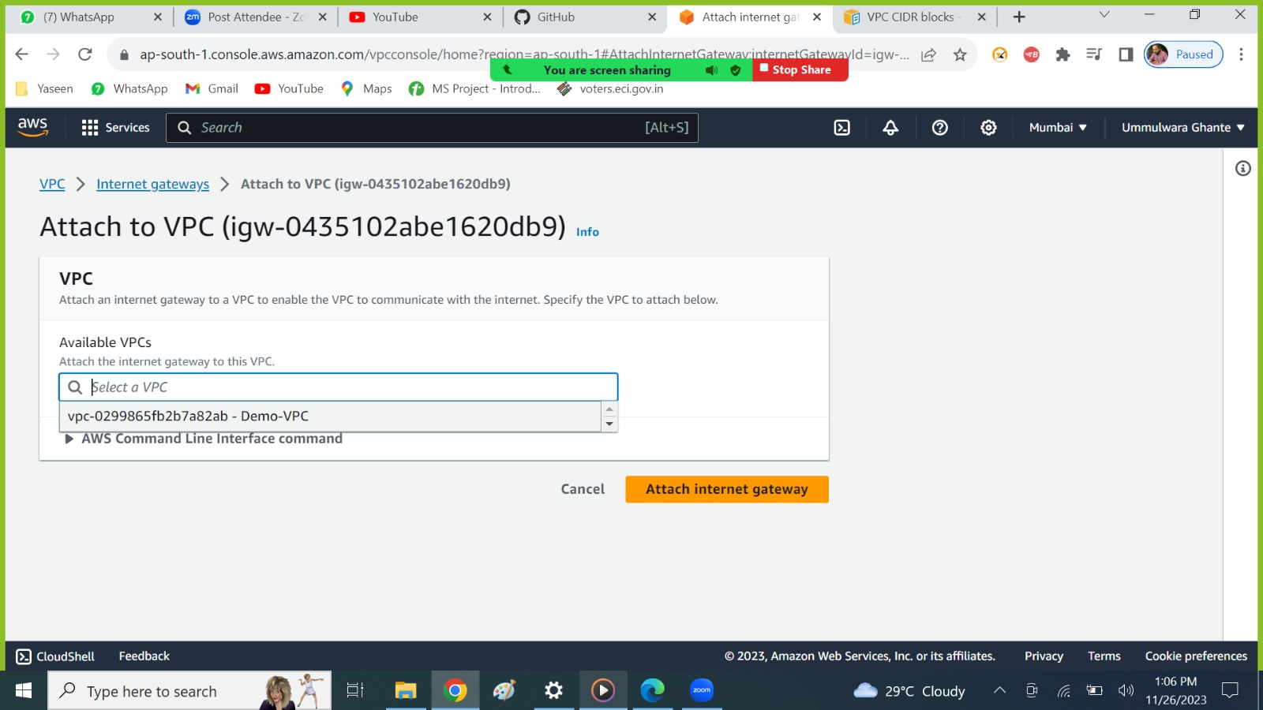

As we can see only 1 VPC is available here because another IGW attached to VPC’s successfully.

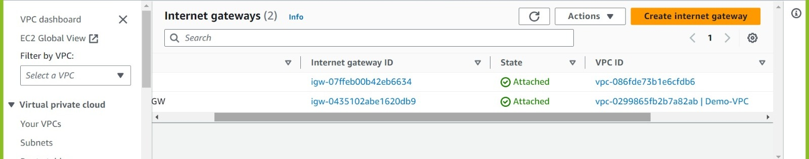

Attached successfully

## 4. Create a Subnet

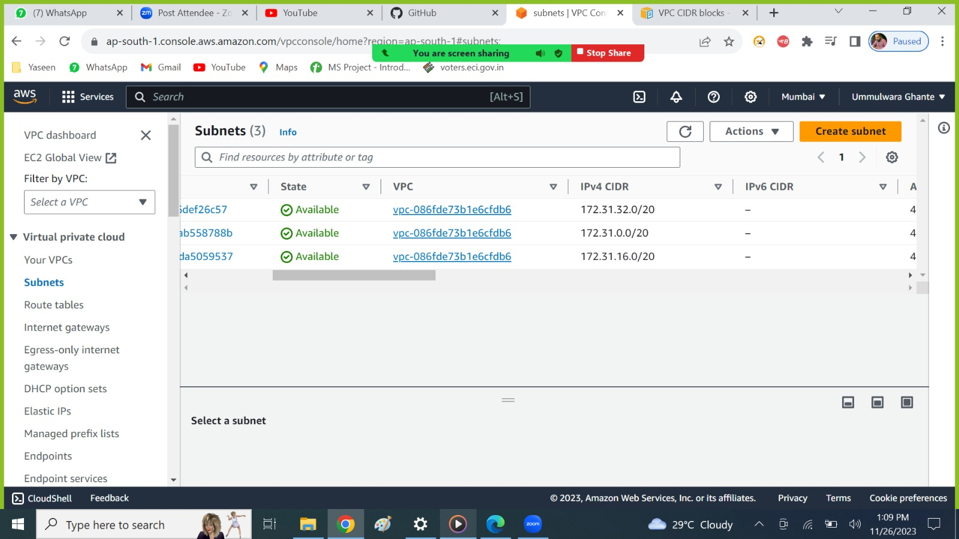

* As we can see these are the default subnets in multiple AZ from the default VPC we can recognize from the (CIDR or Default VPC ID)
* As this is IPV4 CIDR we have total 32 bits and CIDR /20
* /20🡪 These are network bits
* so, the total IP’s we will get from this CIDR is ?
* so, we need to find for the host bits for this network = (32-20=12) (12🡪host bits)
* To calculate IP’s, we require the formula:

= 2^(32-20)

= 2^(12)

= 4096

* AWS will reserve 5 IPs for some use cases – So (4096-5)= 4091
* So, the total IP’s left for this network is = 4091.

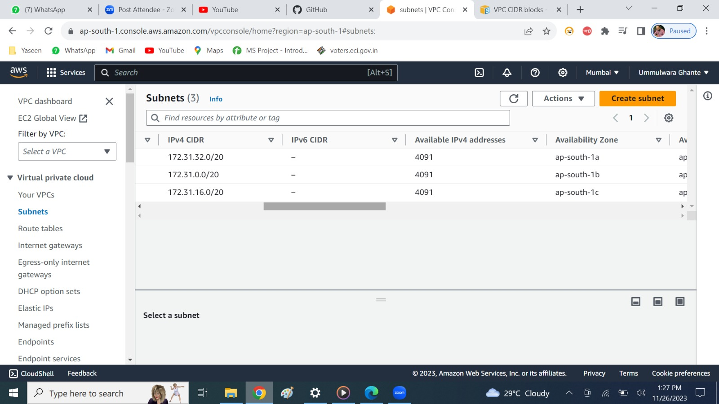

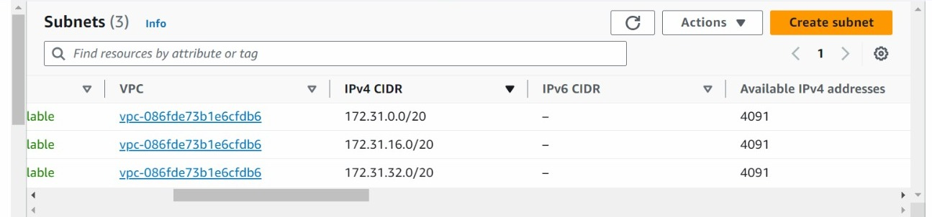

Here for the default subnet the first network is (172.31.0.0/20)

172.31.0.0/20

/20🡪 network bits, 32= Total Bits, Host Bits = (32-20 = 12)

**IPV4 Layout**

0 0 0 1

If we consider 1st bit of the network as 1 then that will be considered as next network range

128 64 32 16

8 4 2 1

0 0 0 0 0 0 0 0

0 0 0 0

0 1 0 0

Host Bits

Network Bits

4 bits

4 bits

8 bits

8 bits

8 bits

* First Network – 172.32.0.0/20
* Now the 2nd new network range will start from 172.31.16.0/20 as ( 0 0 0 1 )
* Next ( 0 0 1 0 ) then the 3rd next range will be start from (172.31.32.0 /20)
* Next ( 0 0 1 1 ) then the 4th next range will be start from (172.31.48.0/20).



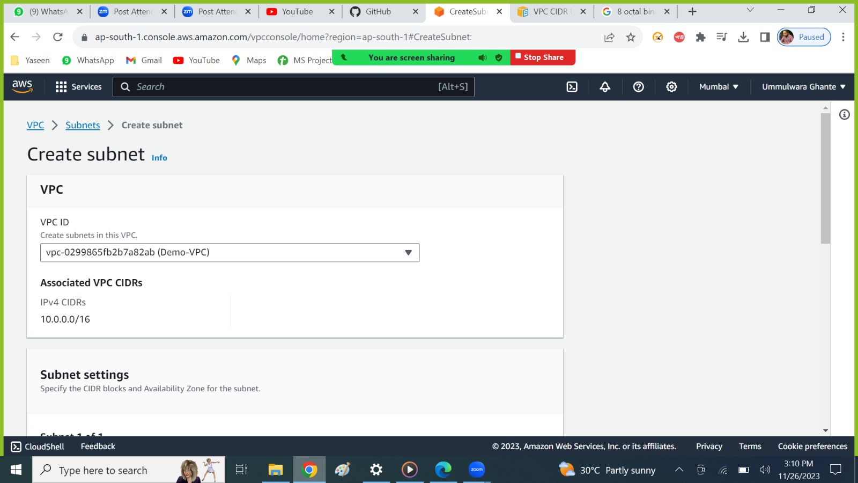

Select the VPC for which you want to associate with this subnet.

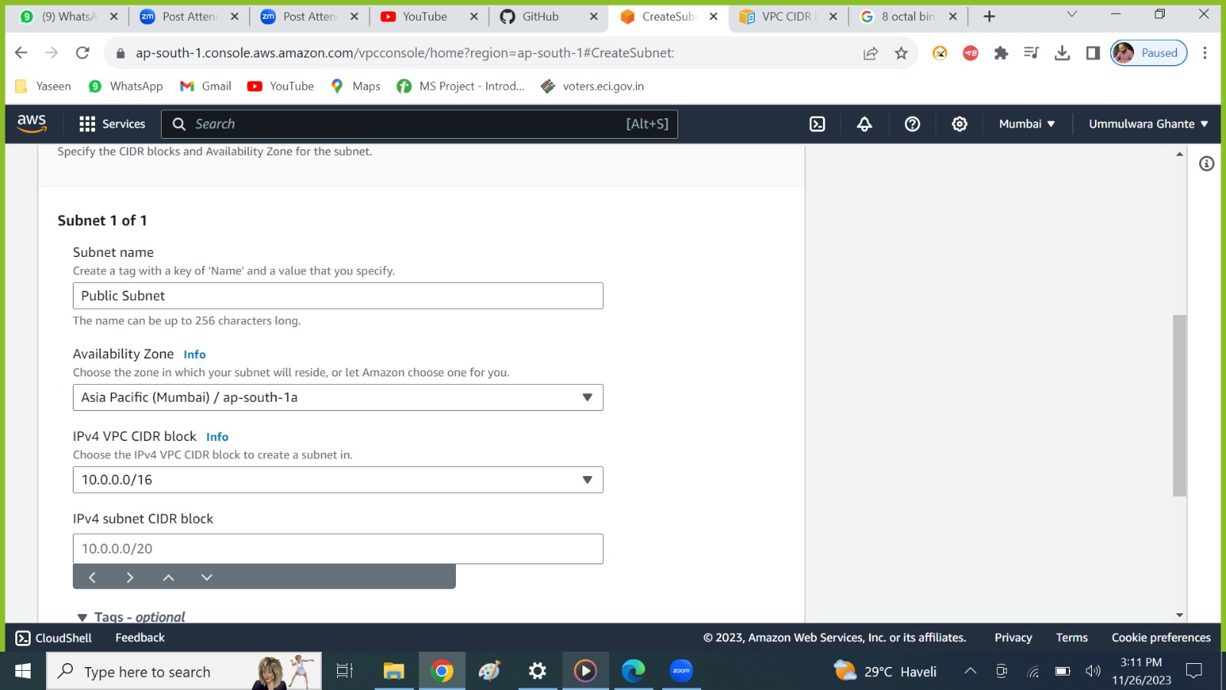

* One subnet can be created in one AZ
* 1 Subnet---> 1AZ

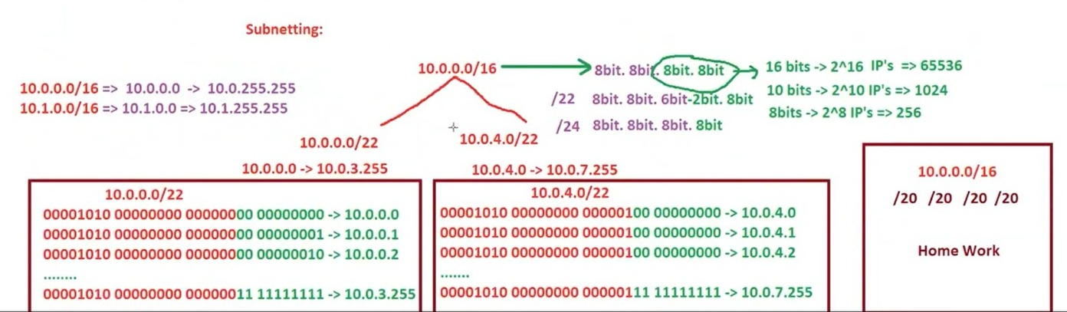

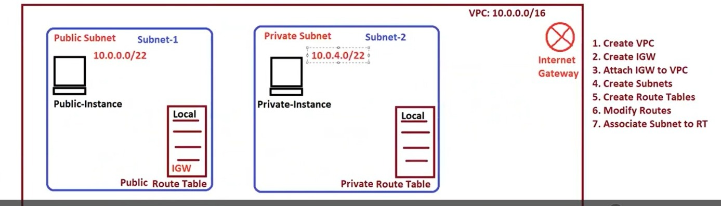

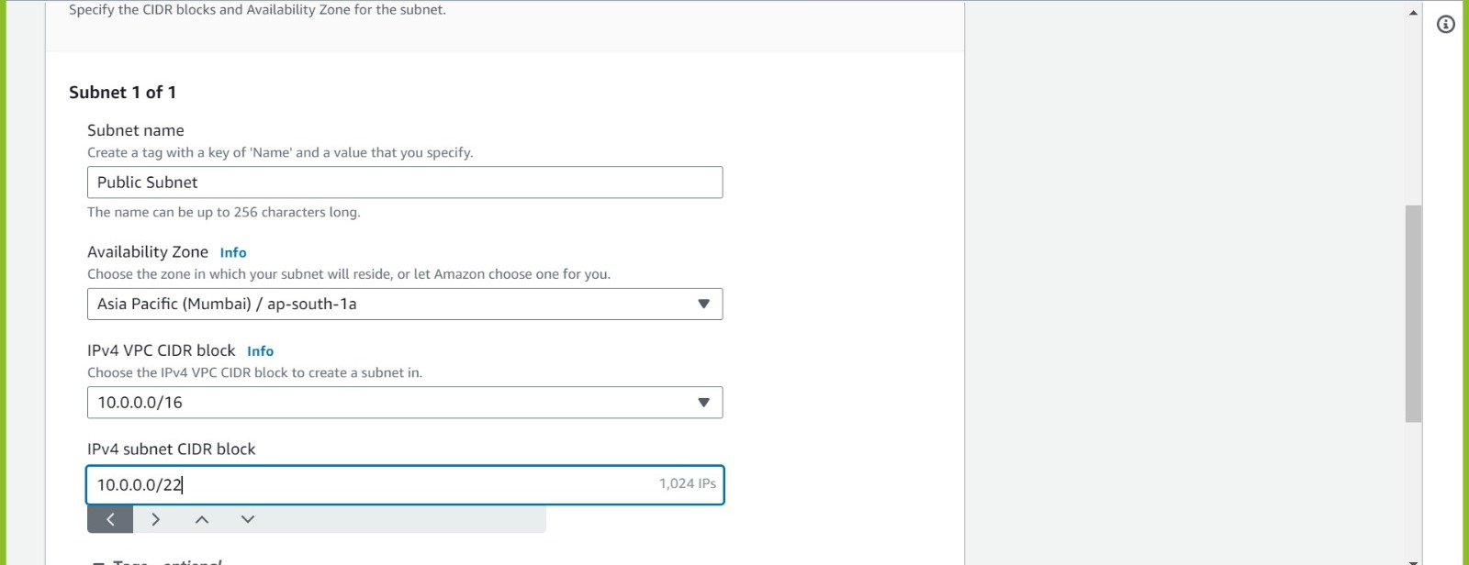

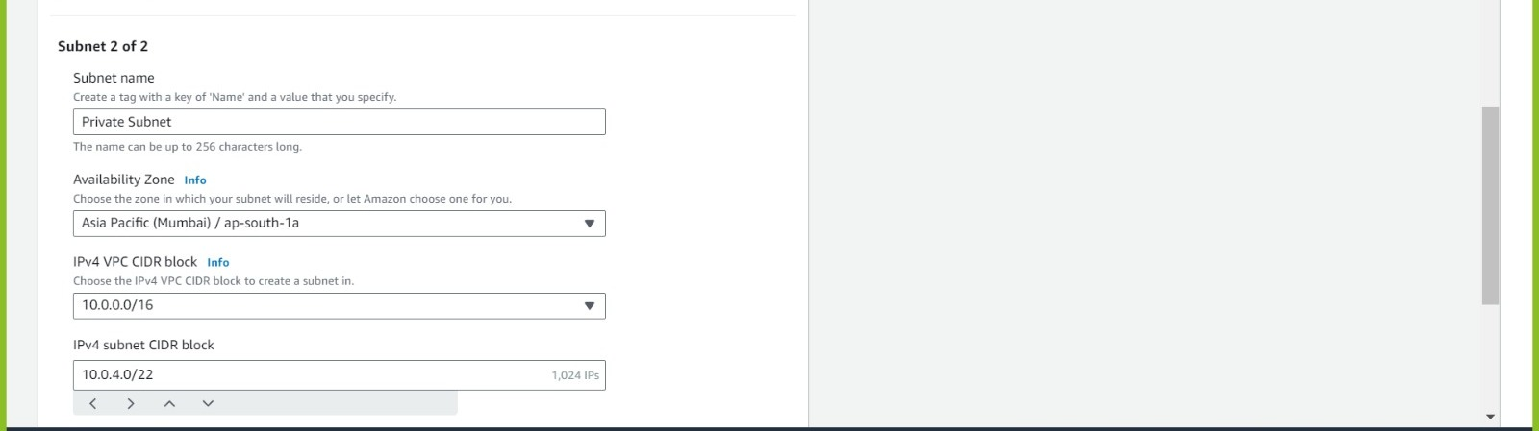

* As in One AZ we can have multiple subnets
* As we can see in subnet 1, we have also provided as AZ-1A and in subnet 2.
* One AZ 🡪 Multiple subnet
* If we create same CIDR for public and private subnet with the same AZ as 1A then subnet will not be created as because if we have same AZ for both the subnets (Public and private) then the CIDR block for that subnet should be different.

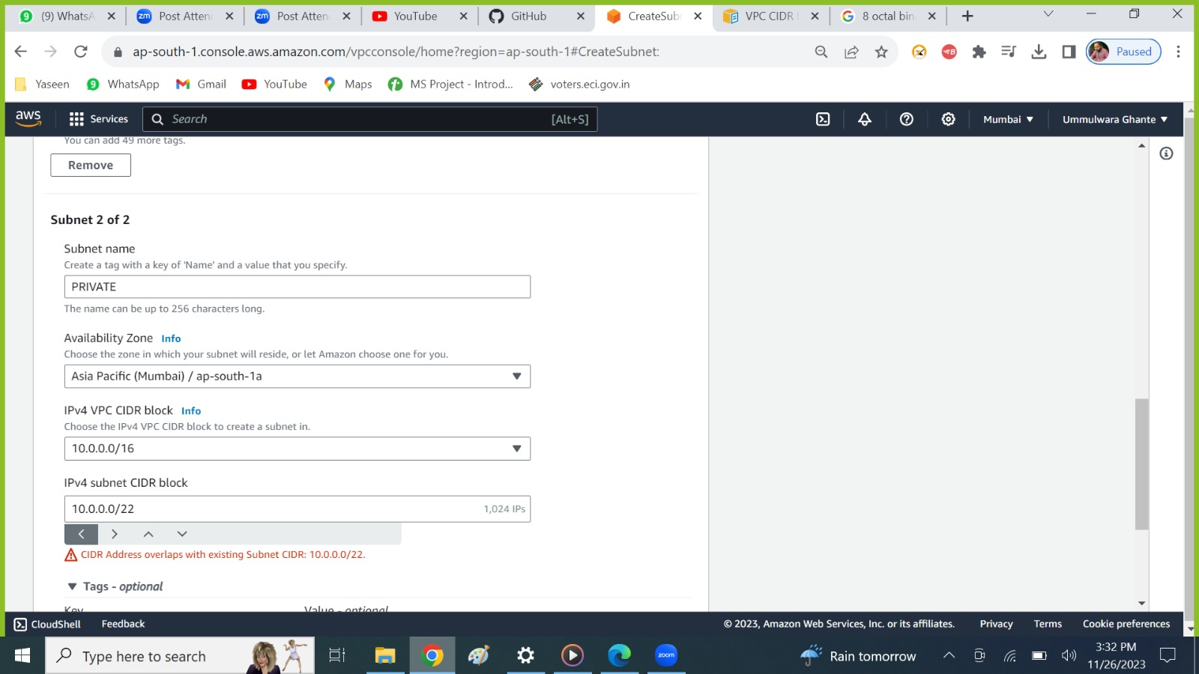

* 1 CIDR 🡪 1 Subnet

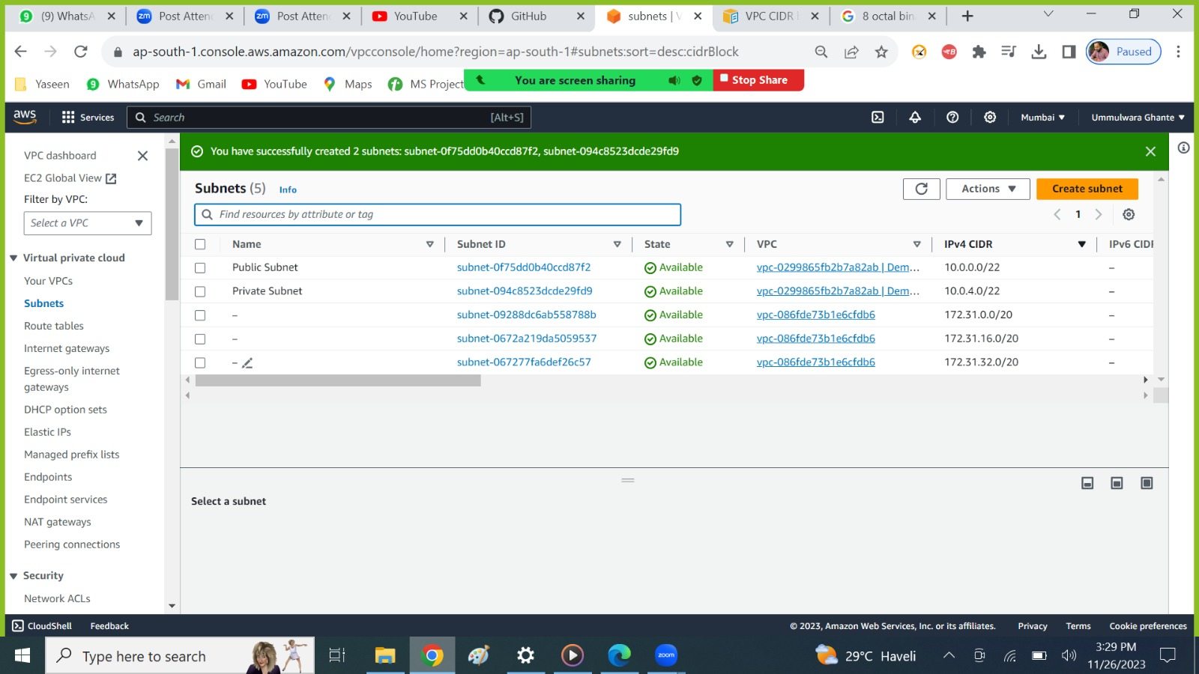

Here Subnet has been created successfully with same AZ but different CIDR.

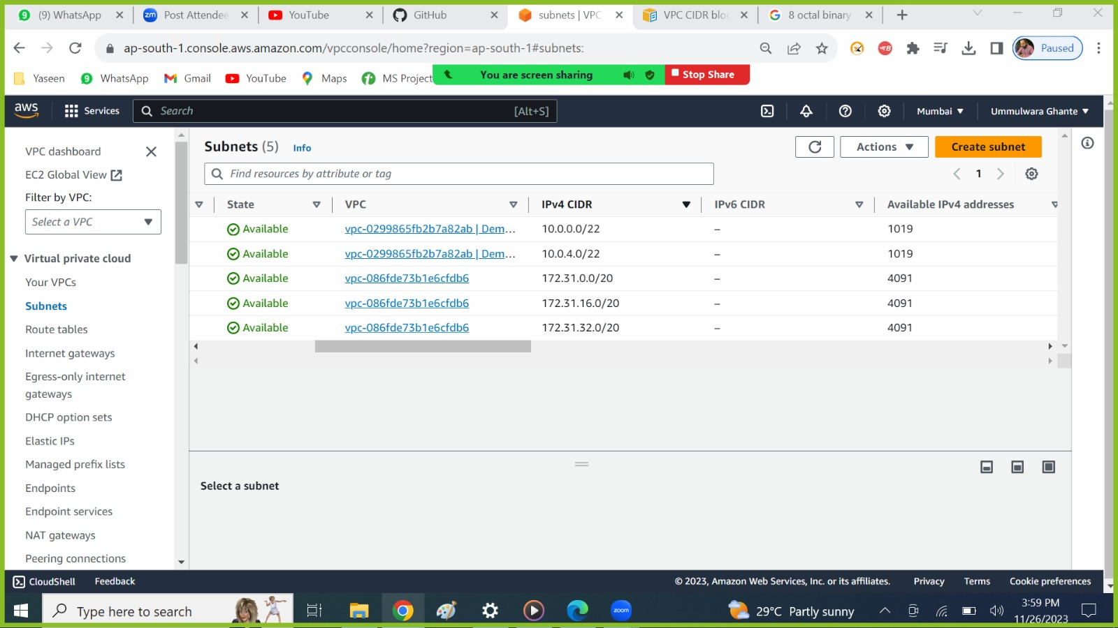

/22-> network bits, 32🡪 total bits, (32-22=10 host bits)

Formula to calculate IP’s

= 2^(32-22)

=10

=1024-5

=1019

As 5 IP’s reserved for AWS

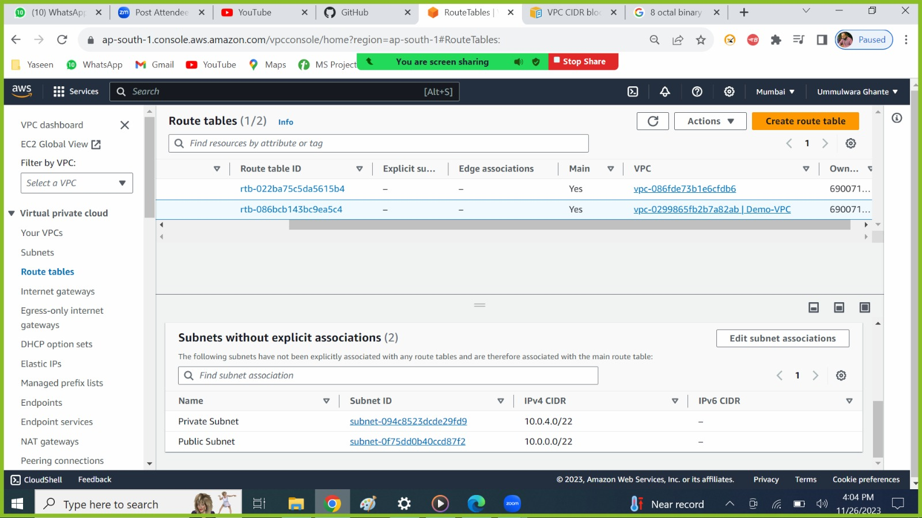

* This is the RT which has been created automatically when we create a VPC
* Implicitly associated subnet to the Demo-VPC

## 5. Create a Route Table

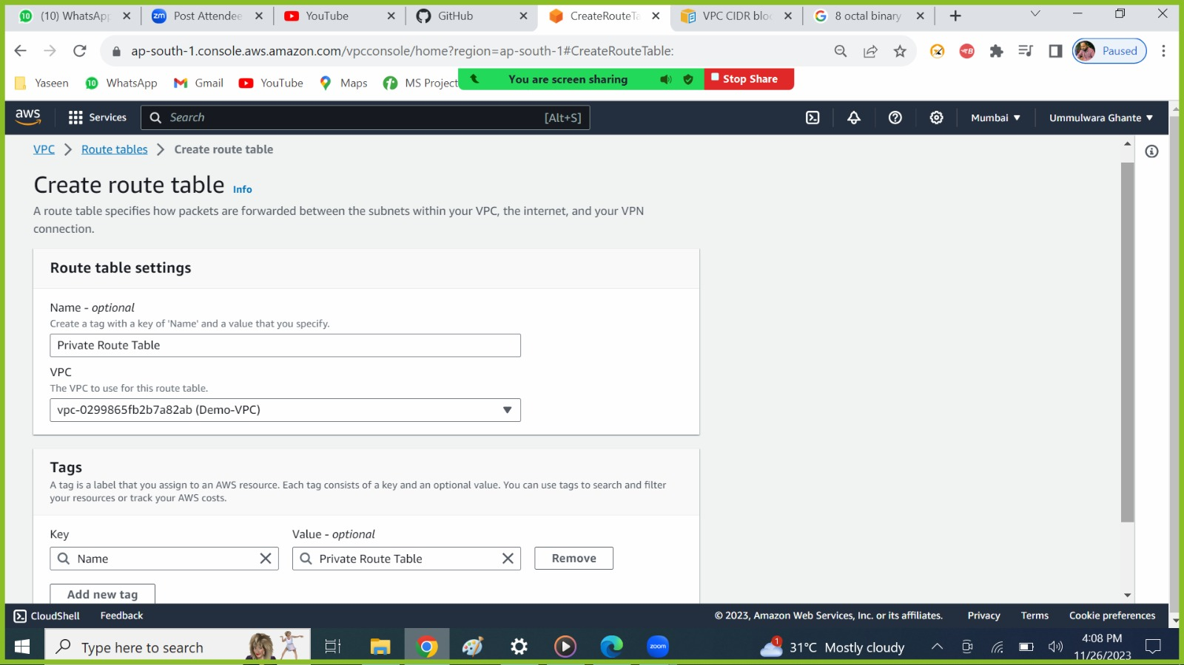

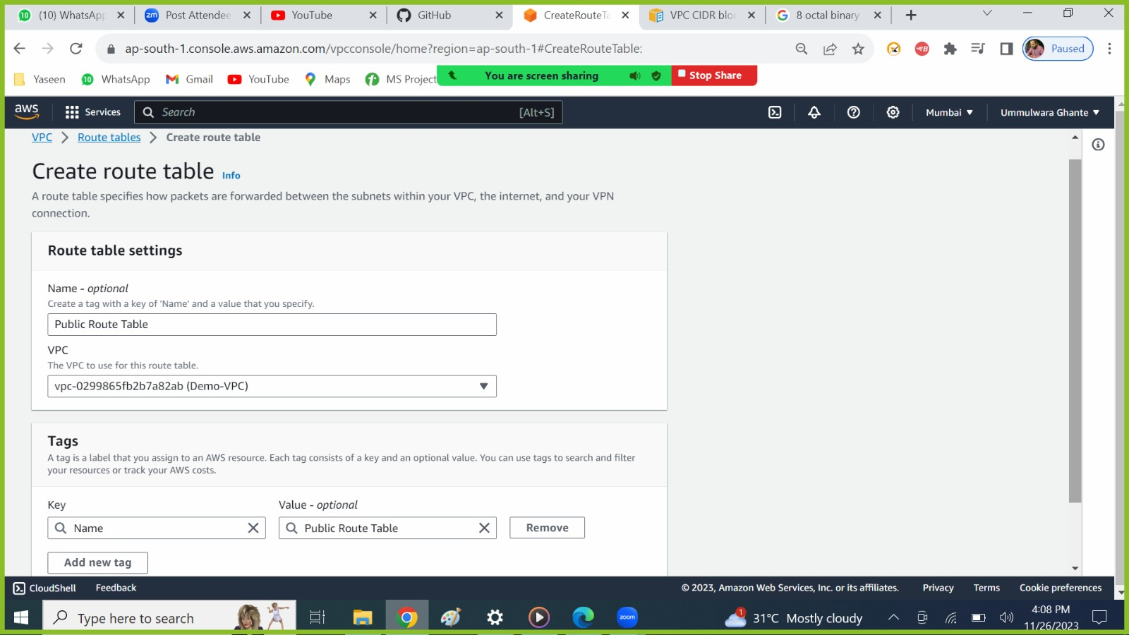

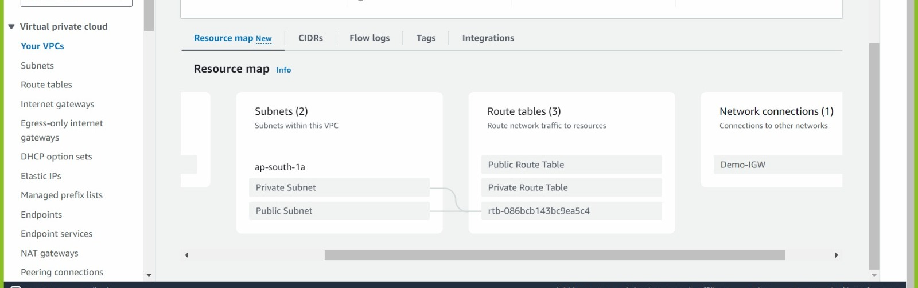



* As we can see in VPC resource map
* our subnets are connected to the default RT now we need to associate these subnets to (Public Subnet--->Public RT) and (Private Subnet--->Private RT).
* Then route the traffic of public RT to IGW.

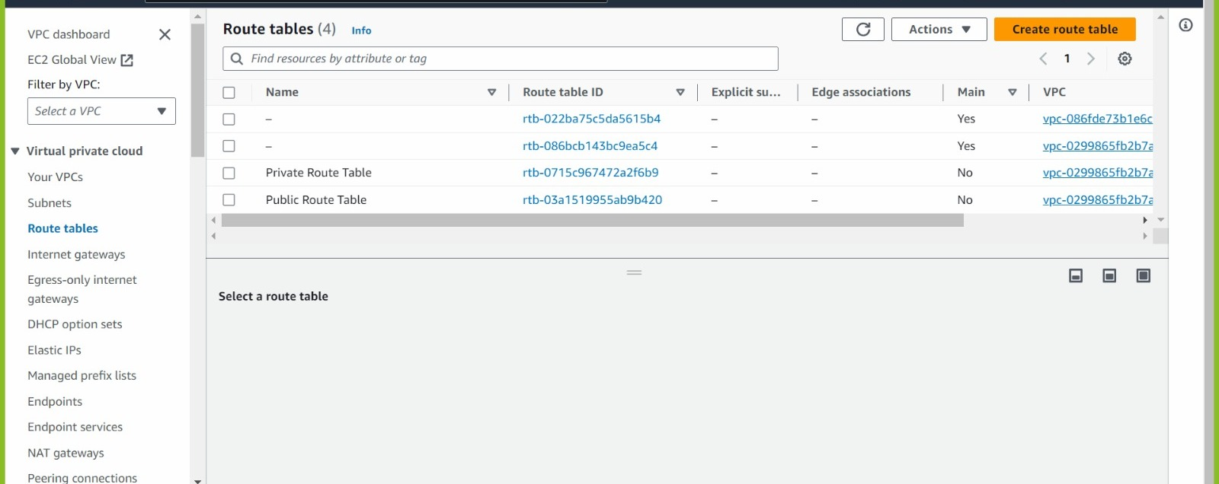

* As we can see our created (public and private RT) are not in main RT
* As it is not associate to any subnets.

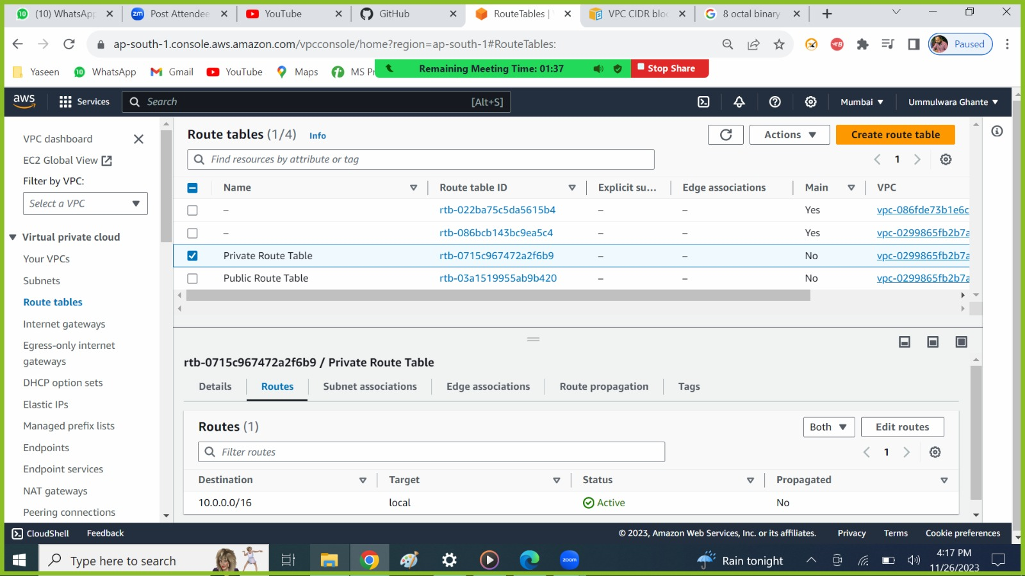

By default, we have only local route so internet cannot pass or go through this network for Private subnet.

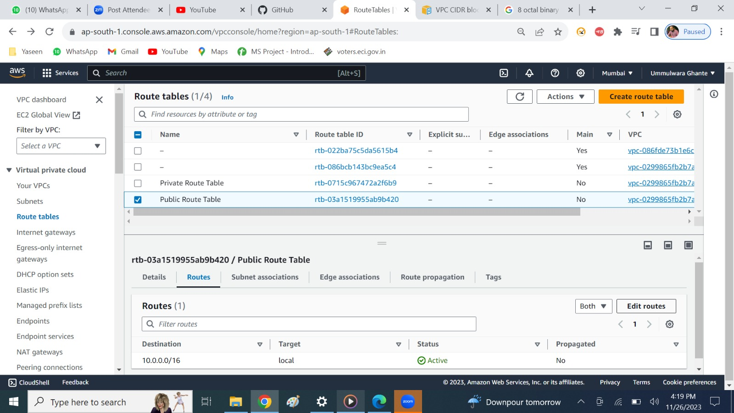

Edit the Public RT Route and give permission to the Internet-gateway.

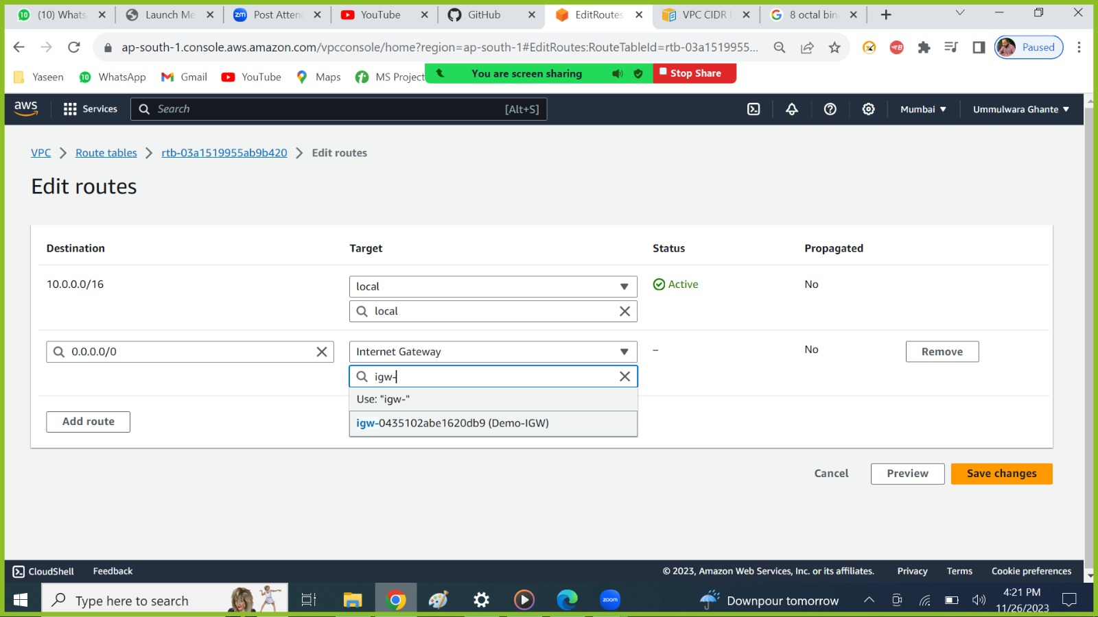

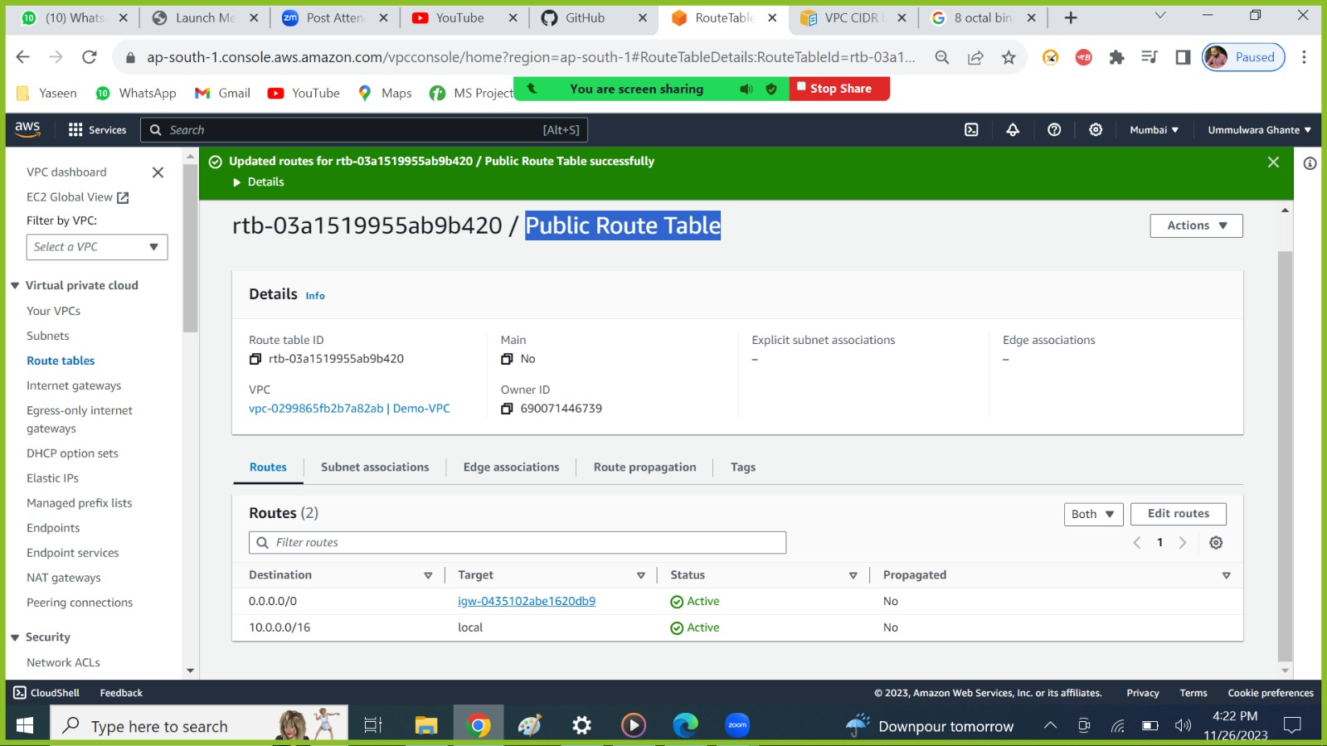

* As we do not know exact IPs of the network (google, amazon etc.) so we use
* 0.0.0.0/0 -- Is specify cox we do not the exact Ip's of the networks (google, amazon etc).

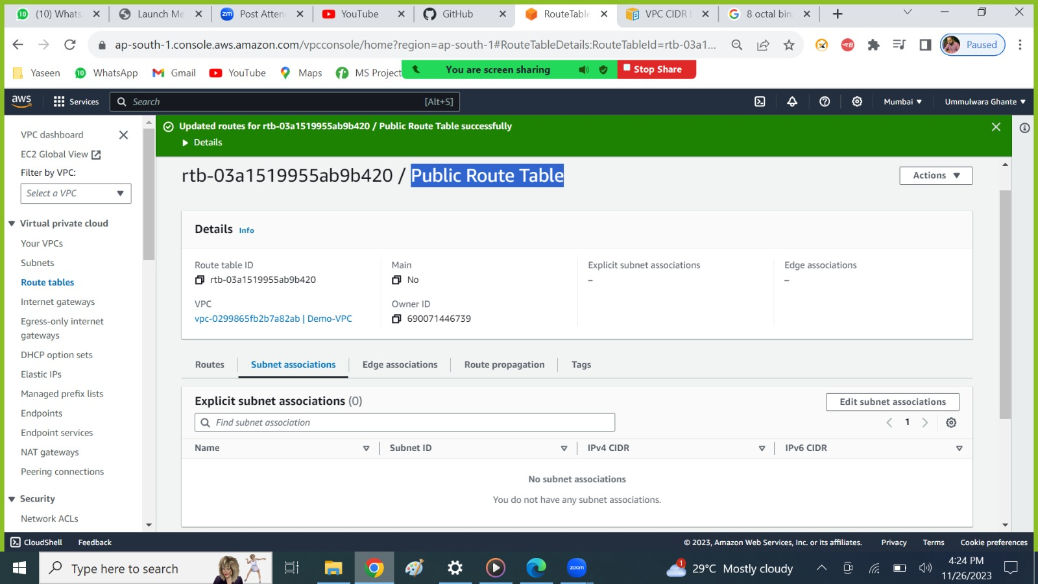

* As no subnet is associated to this RT(Public)
* Explicitly we need to do that.

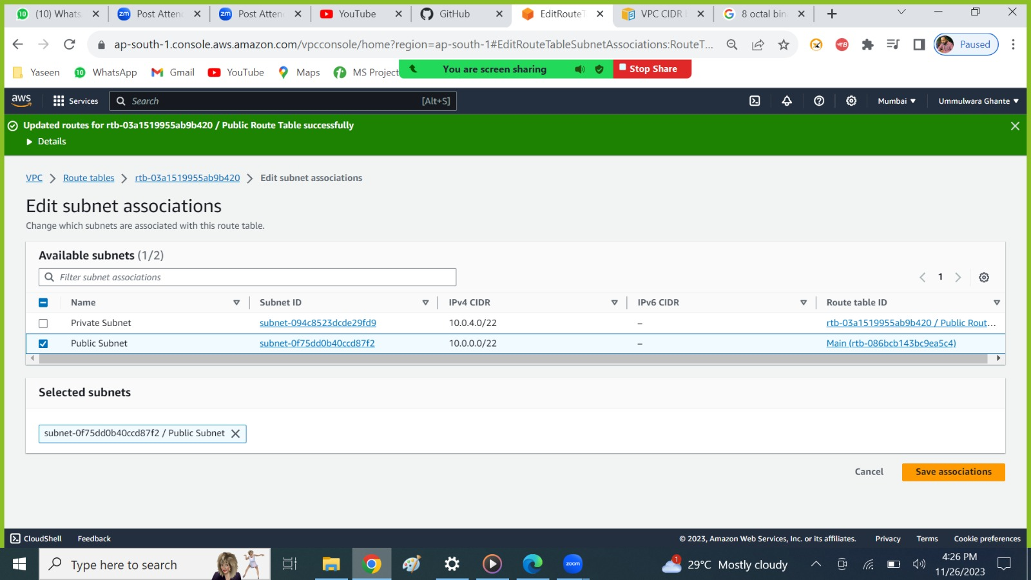

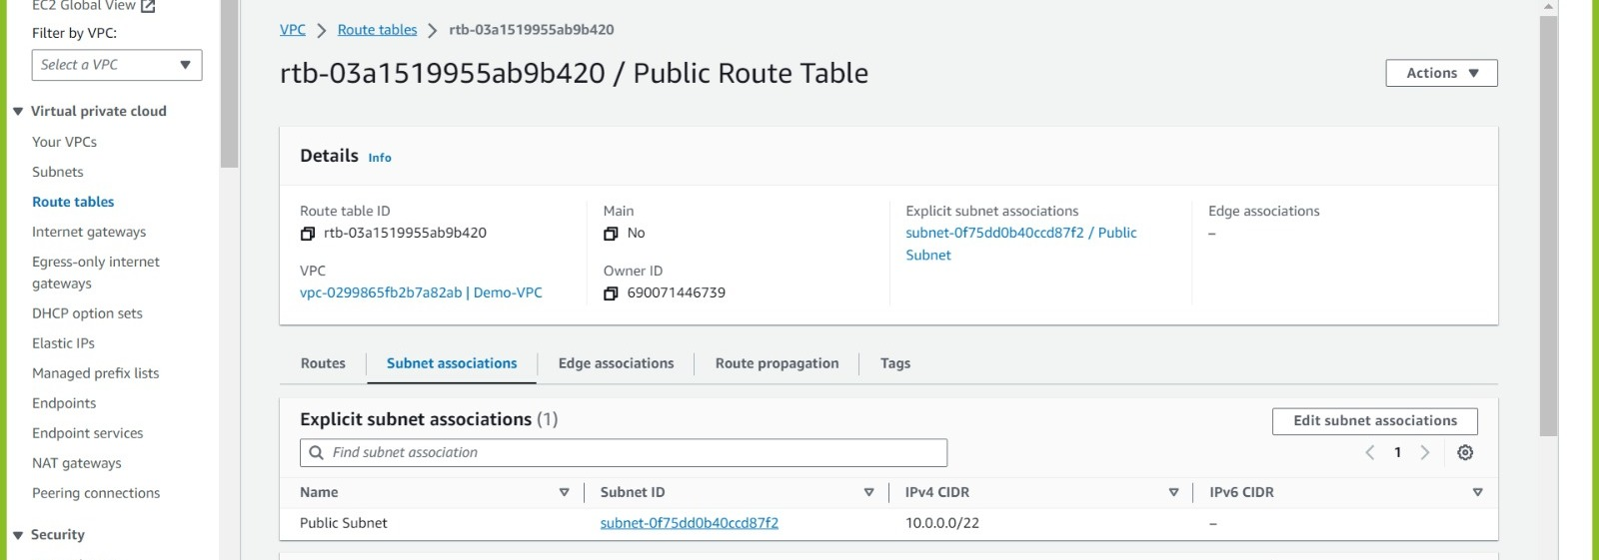

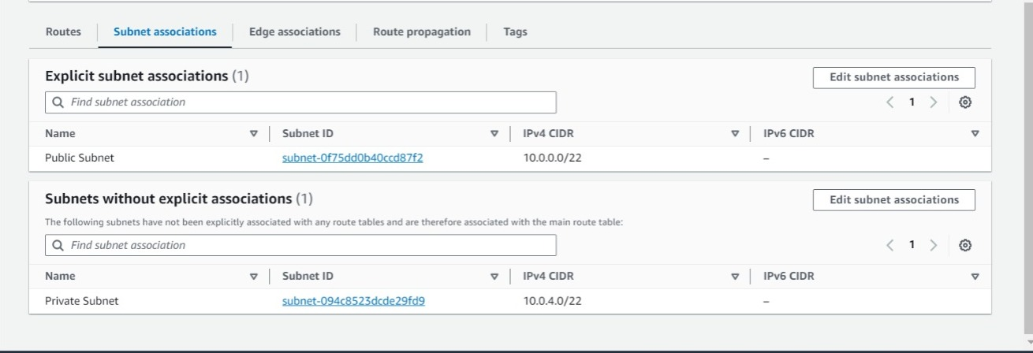

* Same do as for Private

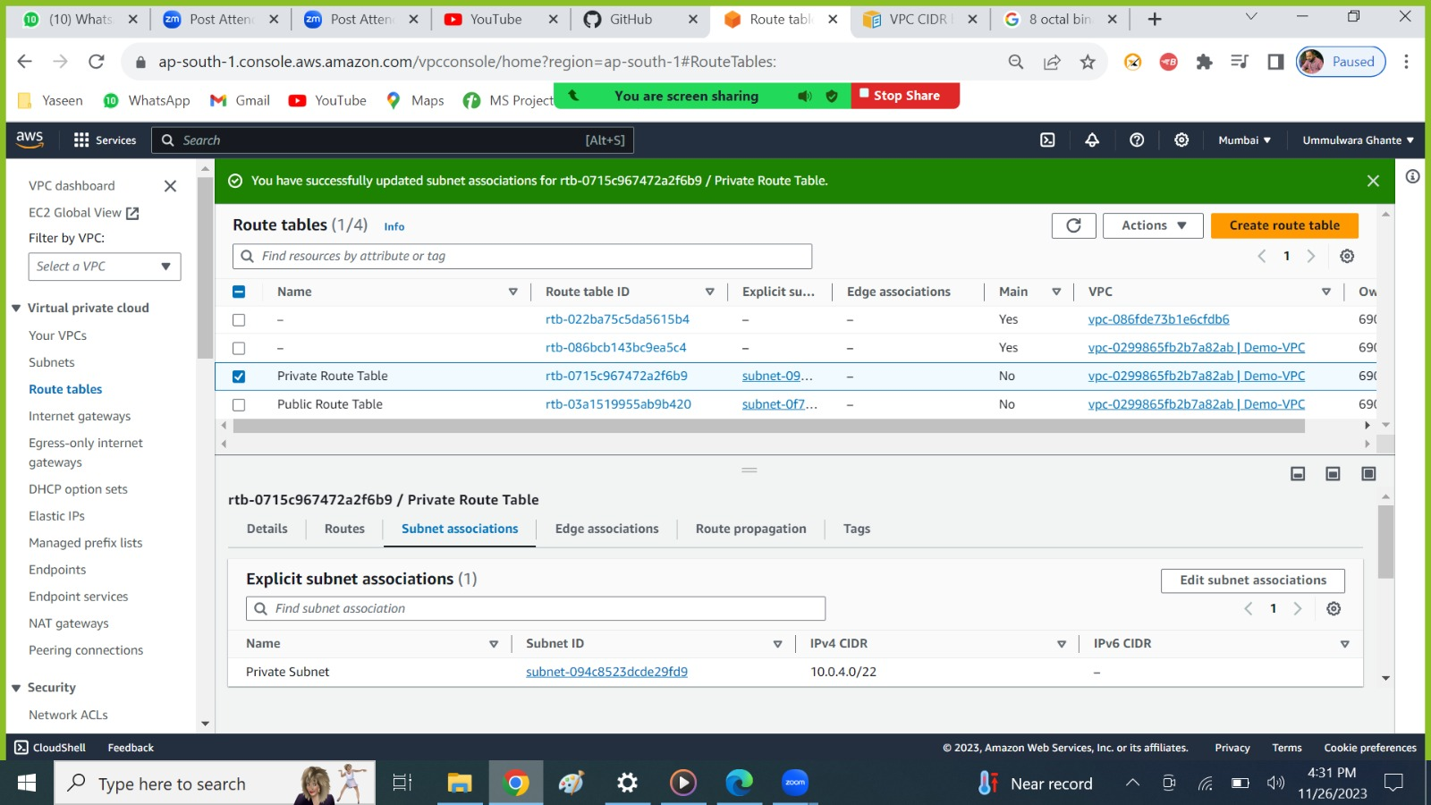

## Route Table More Info

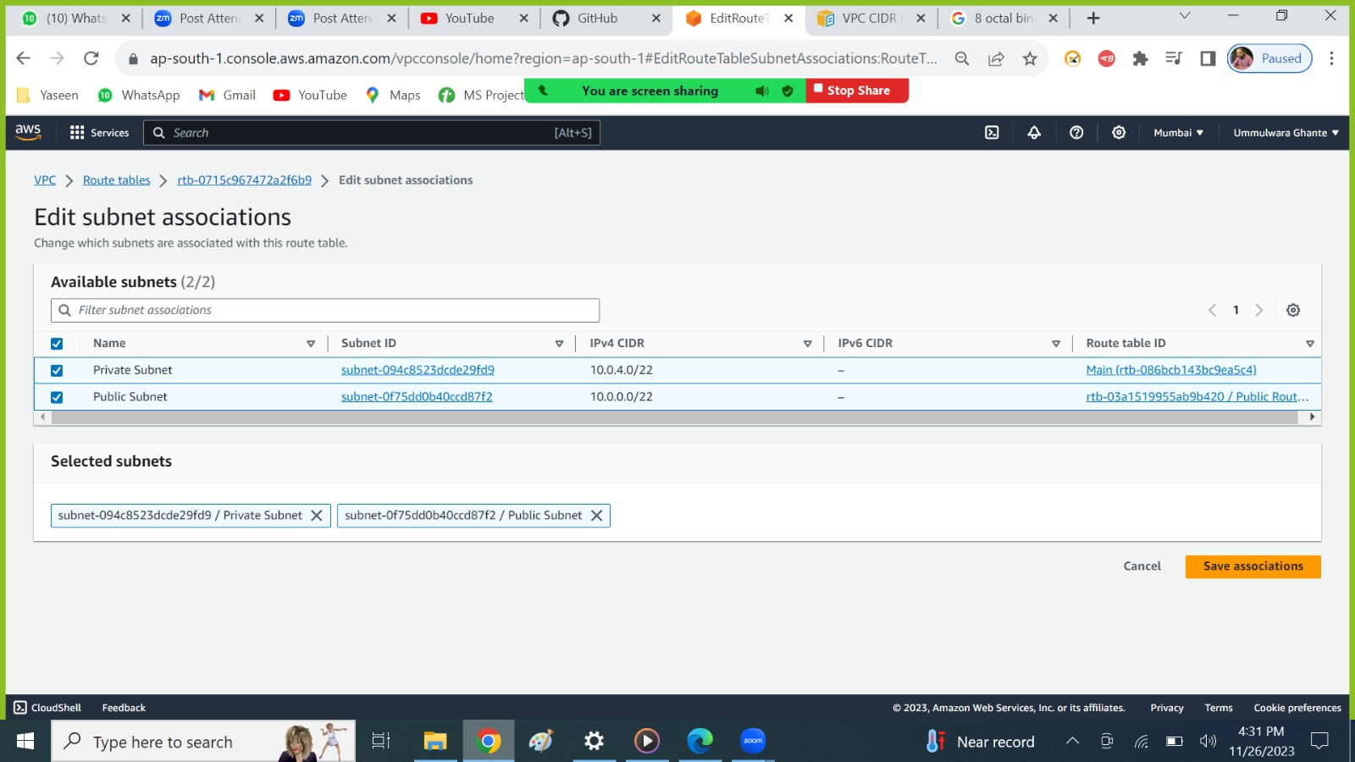

As we can see we can associate multiple subnets to one RT ( that is Private RT)

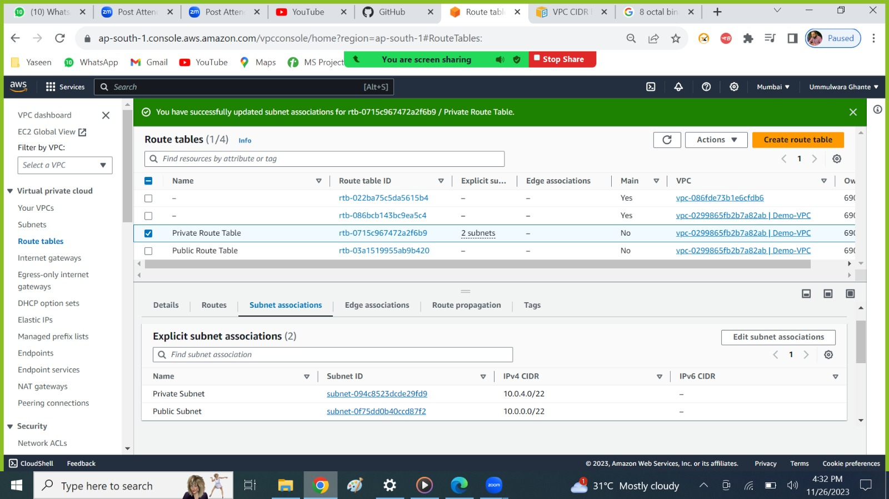



* One RT🡪 Multiple Subnets

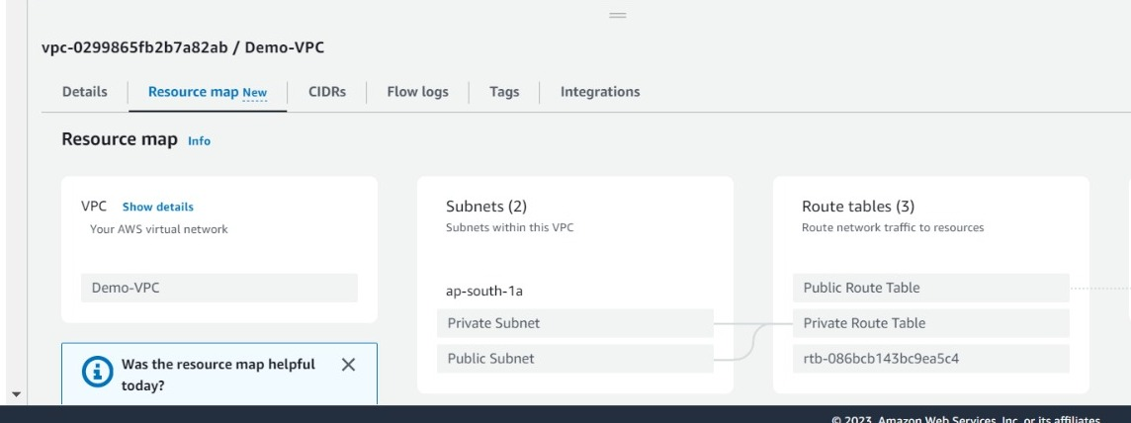

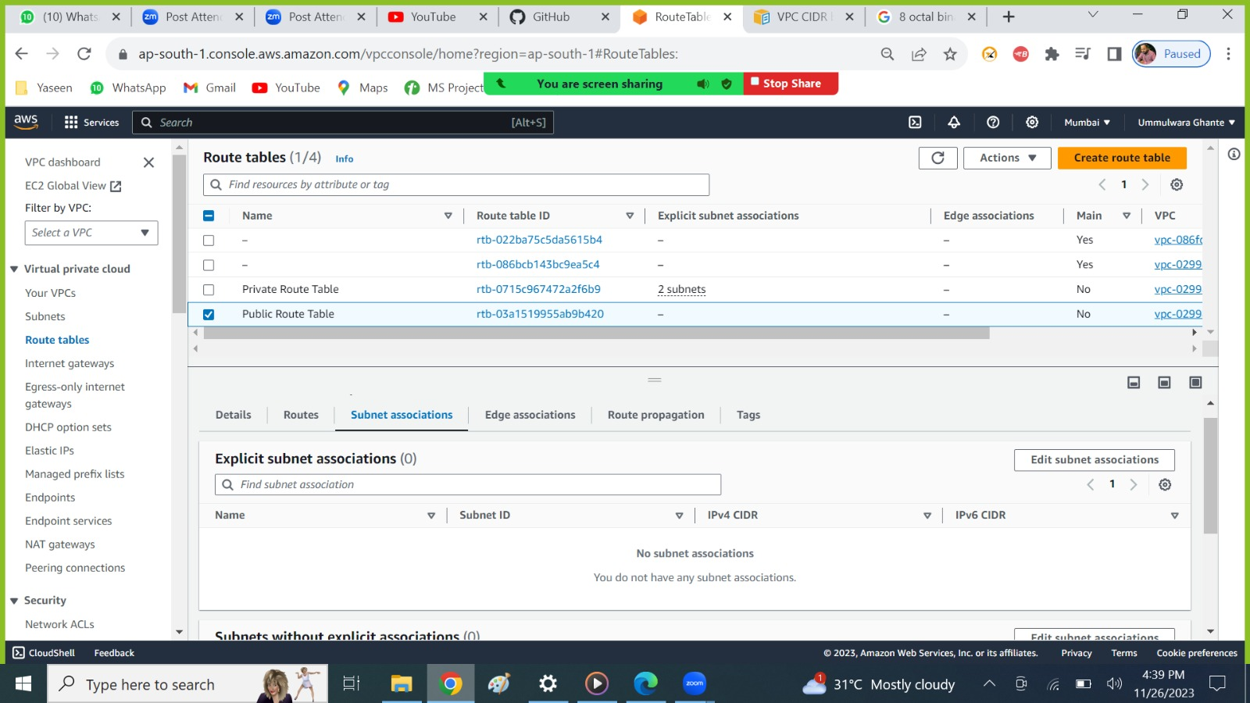



* Here we do not have subnet associated with the public RT because one subnet can be associated with only one RT
* As when we were associating private RT to two subnets (Private and Public) so automatically the public subnet gets disassociated from the public RT and gets attached to the private RT.
* One subnet 🡪 One RT.